**Software requirements Specification**

**For Poker Sini Beta App**



**<<Version 1.0>>**

**October 3rd 2022**

**Created by Ilay Asayag**

# Table of Contents

1. **Introduction…………………………………….…………………….………………….………3**
   1. Purpose……………………………………………………………………….…………………………………….……………...3
   2. Context..……………………………………………………………………………….……………………………………….…..3
   3. Objectives………………………………………………………………………….………………………………….……….…..3
2. **Game Review…………………………………………………………………….……………...3**
   1. Basic Rules………………………………………………………………………………………….………………………….….4
   2. Game Routine…………………………………………………………………………………….………………………….….4
      1. Deal Flop……………………………………………………………………………………………………….…...4
      2. Turn………………………………………………………………………………..……………………………..…..4
      3. Finals…………………………………………………………………………..…………………………………..…4
      4. Reveal…………………………………………………………………………………………………………………4
   3. Basic Probability Strategy…………………………………………………….……………..………………………………..4
   4. Game Currency……………………………………………………………………………….…..……………………………..4
   5. App Goals………………………………………………………………………………………..………………….……………..5
3. **User Requirements……………………………………………………………..…………….5**
   1. Software Interfaces…………………………………………………………………..…………….………..…………………5
   2. Marketing and Target Audience……………………………………………………………...….…….…………………5
      1. Game Characteristics………………….……………………………………………….….……………………5
         1. Gambling……………………………………….………………………………..…….……………………..5
         2. Probability…………………………………………………………………………………….………………5
         3. Time and Game routine……………………………………………………………….……………….6
      2. User Characteristics ………………………………..……………………….…………………….……………6
   3. Assumptions and Dependencies……………………………………………………………………………….………...6
4. **System Requirements………………………………………………………..……………...….6**
   1. Functional Requirements……………………………………………………………………………..……………..….…..6
      1. Gaming Requirements……………………………………………..………………………………………....6
      2. Information and Data Requirements………………………………………………………..………….7
      3. Appearance Requirements…………………………………………………………….…………..…..……7
   2. Non-Functional Requirements…………………………………………………………………………………………..…7
5. **Use Cases and User Stories……………………………………………………….....……….8**
   1. 5.1 UC1: Matching with opponent and playing an online game…………………….………..…….….…8
      1. Brief description……………………………………………………………………………………..….……..…8
      2. UML Sequence Diagram………………………………………………..………………………………….….8
      3. Use Case Description………………………………………………………………………………………..….9
      4. Use Case Diagram……………………………………………………………………..……….……….….……9
   2. UC2:Betting on Slot Machine Mode……………………………………………………..……………….….….…….9
      1. Brief Description……………………………………………………………………………….…….……........9
      2. UML Sequence Diagram………………………………………………………………………….…….……10
      3. Use Case Description………………………………………………………………………………….……...10
      4. Slot Machine Algorithm………………………………………………………………………………..…….11
   3. Uses Stories……………………………………………………………………………………….……………………..……….11
6. **Scenes and Screenshots………………………………………………….…………………..12**
   1. Lobby Scene………………………………………………………………………………………….…………………………..12
   2. Game Scene………………………………………………………………………………….……….………………………....12
   3. Slot Machine Scene……………………………………………………..………………………….………………………..13
   4. Tournament Scene………………………………………………………………………………….…………………………13
7. **Prototype development…………………………………………..………………………….13**
   1. Data security…………………………………………………………………………………………………………………..…13
   2. Network Servers……………………………………………………………………………………….……………………….13
   3. Events and Features…………………………………………………………………………….…….………………………14
   4. Store…………………………………………………………………………………………………………..……………………..14

**Poker Sini**

1. **Introduction:**

1.1 **Purpose**:

The purpose of this document is to present a detailed description of the Poker Sini app developed by Ilay Asayag for Android and IOS users. This file will contain information about the App, features it holds, current status of the beta prototype and forecast about the typecast players who could be potential users. This document is intended for both future stakeholders that may find interest in this game and others that wants to learn about the thinking process I did creating this App.

1.2 **Context**:

Poker Sini is a unique card game also known as Five-O Poker. This is a game for both poker fans, card games lovers and strategy gamers. It’s a game that combines potential and statistical thinking based on the poker rules foundation creating a card game so unique that can attract different kind of users that are not the typical Poker target audience.

Poker Sini Beta App designed to be a prototype for my vision to this game and its potential. The app was created to interduce the basic rules of Poker Sini, show its marketing potential and last but not least, be a platform for me to beat my friends online.

1.3 **Objectives**:

1.3.1 The app provides players to play online a game versus other players in cross-platform servers. Users can play in several game rooms with different entry fees.

1.3.1 The app contains a Bot trained to play the game in 3 ranked levels so users will be able to play against it if no other player is online or if they like to keep betting on Coins which is the main currency in this game.

1.3.2 The app contains a Slot Machine features that was build and designed especially for this game. The Slot Machine will function as the main reward system for players in this game.

1.3.3 The app will keep track on user's progress and will reward them based on their success.

1.3.4 The app provides users both interactive and regular tutorial in order to explain users how to play the Game. The tutorial includes basic poker hand rules in order that users who doesn't familiar with poker will be able to play.

1.3.5 The app shall secure users data in order to prevent data been modified by anyone who seek.

1.3.6 The app shall offer new players tutorial and explain them how to play Poker Sini. In addition, the app will also contain an explanation about poker hands ranking system.

**2. Game Review:**

In this section we are going to review the rules and basic logic of the card game called Poker Sini (also known as Five-O Poker).

2.1 **Basic Rules:**

Poker Sini is played by two players, playing 1vs1 game, with a standard 52 cards pack. The players will try to build the best 5 hands of 5 cards each based on Poker's traditional ranking system. Every hand is played against specific hand of the Opponent. The Goal of the game is to win in more hands than your opponent, when most of the time winning 3 hands will guarantee the win. The game is played without any coins bet in the routine. At the beginning of the game both players place the room's entry fee and at the end the winner takes it all.

2.2 **Game Routine:**

2.2.1 **Deal Flop:** Each of the players receives 5 cards placed in a row faced-up. Every card represents a hand and every hand is played against the opponent's hand that in front of it. The player that got the best 5 hands in the biggening will start.

2.2.2: **Turn:** In turn, each player draws a card from the deck and places it face-up on one of the five cards that they have, building a column or a hand. In each round, players must place one card on each of their columns before continuing to build the other columns: the columns must be equal in each round. This round is played until every hand has 4 cards.

2.2.3: **River:** The last round, also called River round is special. The players will place their cards faced-down so the opponent won't know what card they got. This is where a good bluff can change the game.

2.2.4 **Finals:** After all hands got 5 cards – 4 faced-up and one faced-down every player get 1 final card. The players can throw it, or if they chose, they can replace the card with one of their faced-down cards.

2.2.5 **Reveal:** When the game is over, both players reveal their face-down cards one column at a time. The player that got better poker hand wins the column and score a point. The winner is the one with more points at the end of the game.

2.3 **Basic Probability Strategy:**

Because the game is played with all of the pack cards and most of the cards are faced-up players can "count cards" and estimate their winning probability in each hand. For example, a player that is waiting for a 10 in one hand can count all 10 cards that has picked up from the deck and playing accordingly. Another good example is "trashing" a hand with low winning probability in order to build other hands as strong as possible.

2.4 **Game Currency:**

2.4.1 Coins: The app's main currency is coins. User will bet their coins playing Poker Sini games. Coins is also the main prize in the Slot Machines as players will bet on coins in order to win more and double their investment.

2.4.2 Gems: Another currency in the game is gems. Gems are traded in this version of the game exclusively in Slot Machine mode. Players can buy slot machine packs hoping winning prizes. Future use of Gems can be customized user's players and profile, entering special game events and purchasing game features.

2.5 **App Goals**

2.5.1 Collecting coins – users will try to collect as much coins as they can. Classic capitalism at its finest.

2.5.2 Complete Hands Book – list of all possible poker hands. Every time a player wins with a hand he hasn't won before (Pair of Q, Flush of Diamonds, etc.), he will be rewarded with packs and prizes and the hand's symbol in the Hands Book will be colored. Finishing the entire book is a mission players will need to work hard in order to complete.

2.5.3 Tournaments – After achieving 100k players will be able to start competing in tournaments. Some tournaments demand players to win smaller tournaments in order to participate.

**3. User Requirements:**

3.1 **Software Interfaces:**

Poker Sini App were developed in Unity so it can run on several platforms, but the App main purpose is to be a mobile game designed for Android and IOS.

3.2 **Marketing and Target Audience:**

First of all, Poker Sini is a game mostly famous among travelers and other groups that have never played this game in a mobile app format.

Also, as described previously, Poker Sini due its special characteristics is a game that can be targeted into users that won't be targeted as regular poker games potential players. In this section I will try to explore the various users typecasts and why they can be targeted as potential users.

3.2.1 **Game Characteristics:**

In order to understand what attracts users, first we need to explain what distinguish between Poker Sini and other versions of Poker (Texas Holdem, Omaha, etc.). In this section we are not going to explain all of the game rules, but instead we will point out the main reasons Poker Sini can target other audience then regular poker players.

3.2.1.1 **Gambling:** Poker Sini is not a game based on bets and bluffs. Unlike most poker games, in Poker Sini the players won't bet on their cards and there isn't any way a player can alter the game route using more money. At the biggening of the game players will put the same amount of money and the winner at the end will take it all.

3.2.1.2 **Probability:** In Poker Sini there is a use to all of the 52 deck cards. Every player picks a card from the deck in his turn and choose a hand to locate it. This routine continues until at the end of the game every player will hold in his hands 25 cards, after throwing one card, and in total only 11 cards will be hidden from him. This makes the game to be more of a numbers game then game of luck. By looking at the faced-up cards a player can form a strategy based on the probability of winning each hand.

Because of that we can say that although the game is based on the traditional poker rules, this game is more like popular strategic card games that are popular among users who do not play poker at all.

3.2.1.3 **Time and Game routine:** Unlike other poker games, Poker Sini is played only by two players at a time, and because of this and its strategic gameplay, the game is a card game that does not feels different playing against a machine (like Chess, Rami, UNO, etc).

Most of traditional poker games are played as repetitive short games, without any fixed ending. Users will enter a table and just play until they either loses all of their money or, like most of the time, play several rounds until they lose interest in the game. This makes it hard for players to estimate the amount of time they are going to spend playing.

In Poker Sini the average time from the moment you opened the app till the moment you finished a standard game won't be more than three minutes. This and all of the above, makes this app best for "kill" time and enter even when you don't have much time to fully commit to a long gaming session.

3.2.2 **User Characteristics:**

After understanding what distinguish between Poker Sini and other poker games, now we would like to discuss about the common user.

First, no previous experience with this Poker game is required as the app contains a basic tutorial, but the stereotypical user will be one that is probably familiar with the basic rules of Poker's ranking system (Although even this is not necessary).

The common user will be a player that has played poker before in his life, but for various reasons wants a "break" from the regular poker games he played before.

The unique characteristics in Poker Sini as described in 2.2.1 will make this game more appealing to users who does not play poker on their phone from several reasons.

In addition, strategic card games players (Like UNO, Yaniv, etc.) can find this game interesting and maybe even an "entry game" for the Poker gaming world.

3.3 **Assumptions and Dependencies:**

The latest version of the app was developed in Unity version 2020.3.14f1 which means that the app assumptions and dependencies for Android and IOS will be taken straight from Unity's limitations and restrictions.

You can read more about it in the link down below:

https://docs.unity3d.com/Manual/android-sdksetup.html

**4. System Requirements**

In this section we will state and prioritize the system requirements as I foresee them.

4.1 **Functional Requirements:**

Gaming Requirements: 4.1.1

|  |  |  |
| --- | --- | --- |
| Requirement | Priority | ID |
| The App shall allow users to play Poker Sini Games against Other people online no matter what operating system they got in several tables based on different entry fees. | H | G-Req1 |
| The App shall allow users to play against a Bot developed in 3 different difficulty levels in several tables based on different entry fees. | H | G-Req2 |
| The App will Provide players a platform to play 1vs1 games offline using just one phone to practice and play against a friend in person. | H | G-Req3 |
| The App will contain a feature in game mode that counts and inform users what cards hasn't picked yet. | H | G-Req4 |
| The App shall allow users to enter the slot machine rooms and bet on their coins in order to win prizes. | H | G-Req5 |
| The App will reward players on a scale based on the room they played – higher risk means higher rewards. | M | G-Req6 |
| The App will hand out users a daily reward in form of 5 free bets at the Slot Machine mode. | M | G-Req7 |
| The app shall contain a tutorial teaching user to play Poker Sini. | H | G-Req8 |
| The app shall allow users to start tournaments, play some games, stop and return afterwards to continue whenever they likes. | M | G-Req9 |

4.1.2 Information and Data Requirements:

|  |  |  |
| --- | --- | --- |
| Requirement | Priority | ID |
| The App shall keep track on users' success and manage their coins and gems accordingly. | H | I-Req1 |
| The App needs to provide secured database to save all of the user information and data without been leaked or modified by malicious factors. | H | I-Req2 |
| The App will keep track on Player's poker hands in games and will reward them accordingly to their success. | H | I-Req3 |

4.1.3 Appearance Requirements:

|  |  |  |
| --- | --- | --- |
| Requirement | Priority | ID |
| The app should be able to provide a screen that shows the players all of the hands they achieved and list on goals to achieve in future games. | H | A-Req1 |
| The App shall allow users to customize the app's appearance and their profile. | M | A-Req2 |

**Non-Functional Requirements:** 4.2

|  |  |  |
| --- | --- | --- |
| Requirement | Priority | ID |
| Users will be able to enter the app and enter a game in less than 5 seconds. | H | N-Req1 |
| Every table should have a different style and design of cards back, background and Logo. | M | N-Req2 |
| The App shall have at least 10 different room stages with different entry fees. | H | N-Req3 |
| No matter what, Poker Sini game won't take more than 9 minutes and by average a standard game will take 3 minutes online and minute and a half against a bot. | H | N-Req4 |
| The App shall draw cards and placing the last cards of a round automatically in order to speed up the game. | M | N-Req5 |
| In Slot Machine Mode the expected value of daily win rate will be 0.47  While the expected daily revenue will be 1:1 | H | N-Req6 |
| Playing against the easiest bot, average player win rate should be around 0.7. | H | N-Req7 |
| Playing against the second bot, average player win rate should be less than 0.6. | H | N-Req8 |
| Playing against the Hardest bot, intelligent playing player win rate should be less than 0.5. | H | N-Req9 |
| In an online game information will be updated after less than 2 seconds. | H | N-Req10 |

**5 Use Cases and User Stories**

5.1 **UC1:** Matching with opponent and playing an online game.

5.1.1 **Brief Description:**

Two players will log into Photon's servers and try to enter a room suitable to the game properties they wish. One of them, the Host of the game will fail to find open room so he will open one himself, the other will join this room and both will load the game scene together.

Inside the game scene, the host will be owner of all the game object. He will instantiate all of the room object and will be in charge of saving and operate all game data until the game ends.

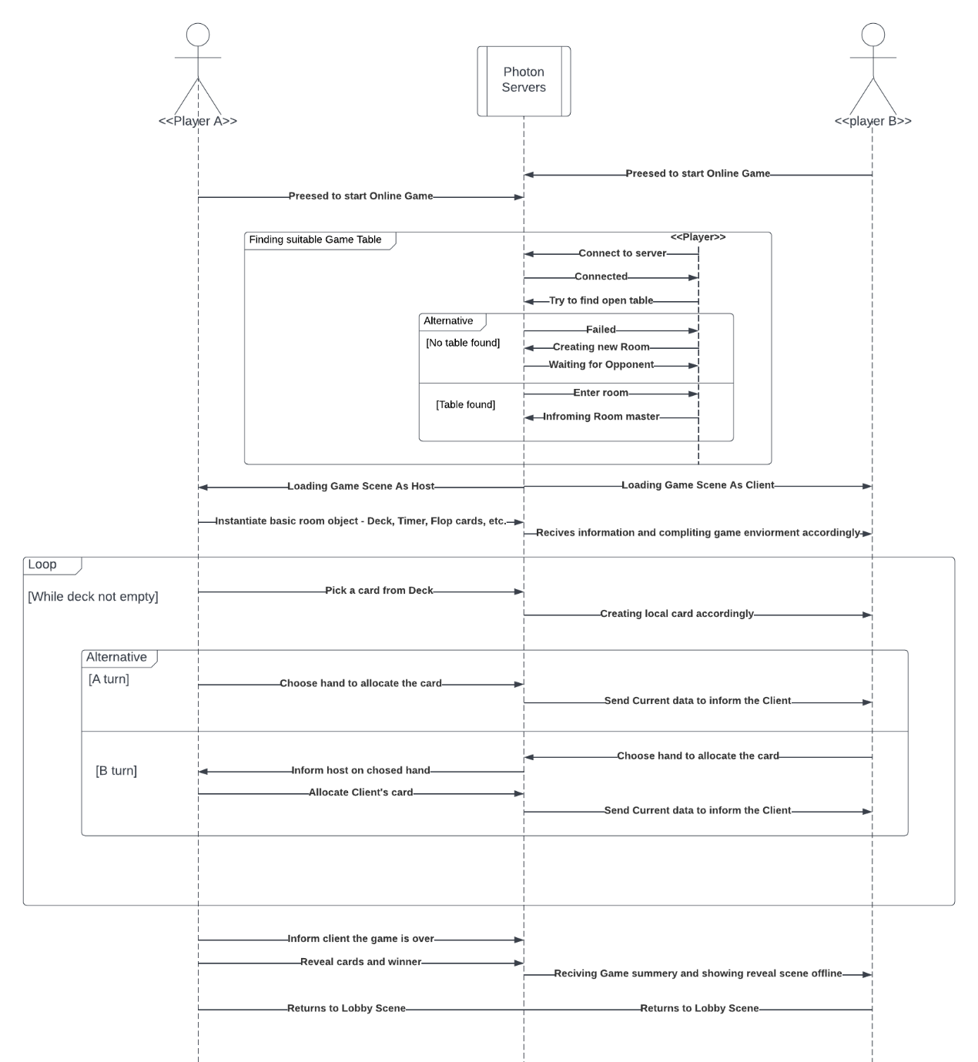5.1.2 **UML Sequence Diagram:**

5.1.3 **Use Case Description:**

|  |  |
| --- | --- |
| UC1: Matching with opponent and playing an online game. | Use Case |
| G-Req1, I-Req1 | **Related Requirements** |
| Player A, Player B, Photon Server | **Actors** |
| * Creating an online room in Photon's servers * Entering the room and instantiate game scene. * Play Full Poker Sini game. * The system rewards the winner accordingly. | **Goals** |
| * Both players have stable internet connection * Both players have enough coins to play in the table they chose. | **Preconditions** |
| The room was created and the players finished the game successfully. | **Postconditions** |
| An online error creates a failure, both players disconnect from the server and gets their money back. | **Alternative Scenario** |

5.1.4 **Use Case Diagram:**

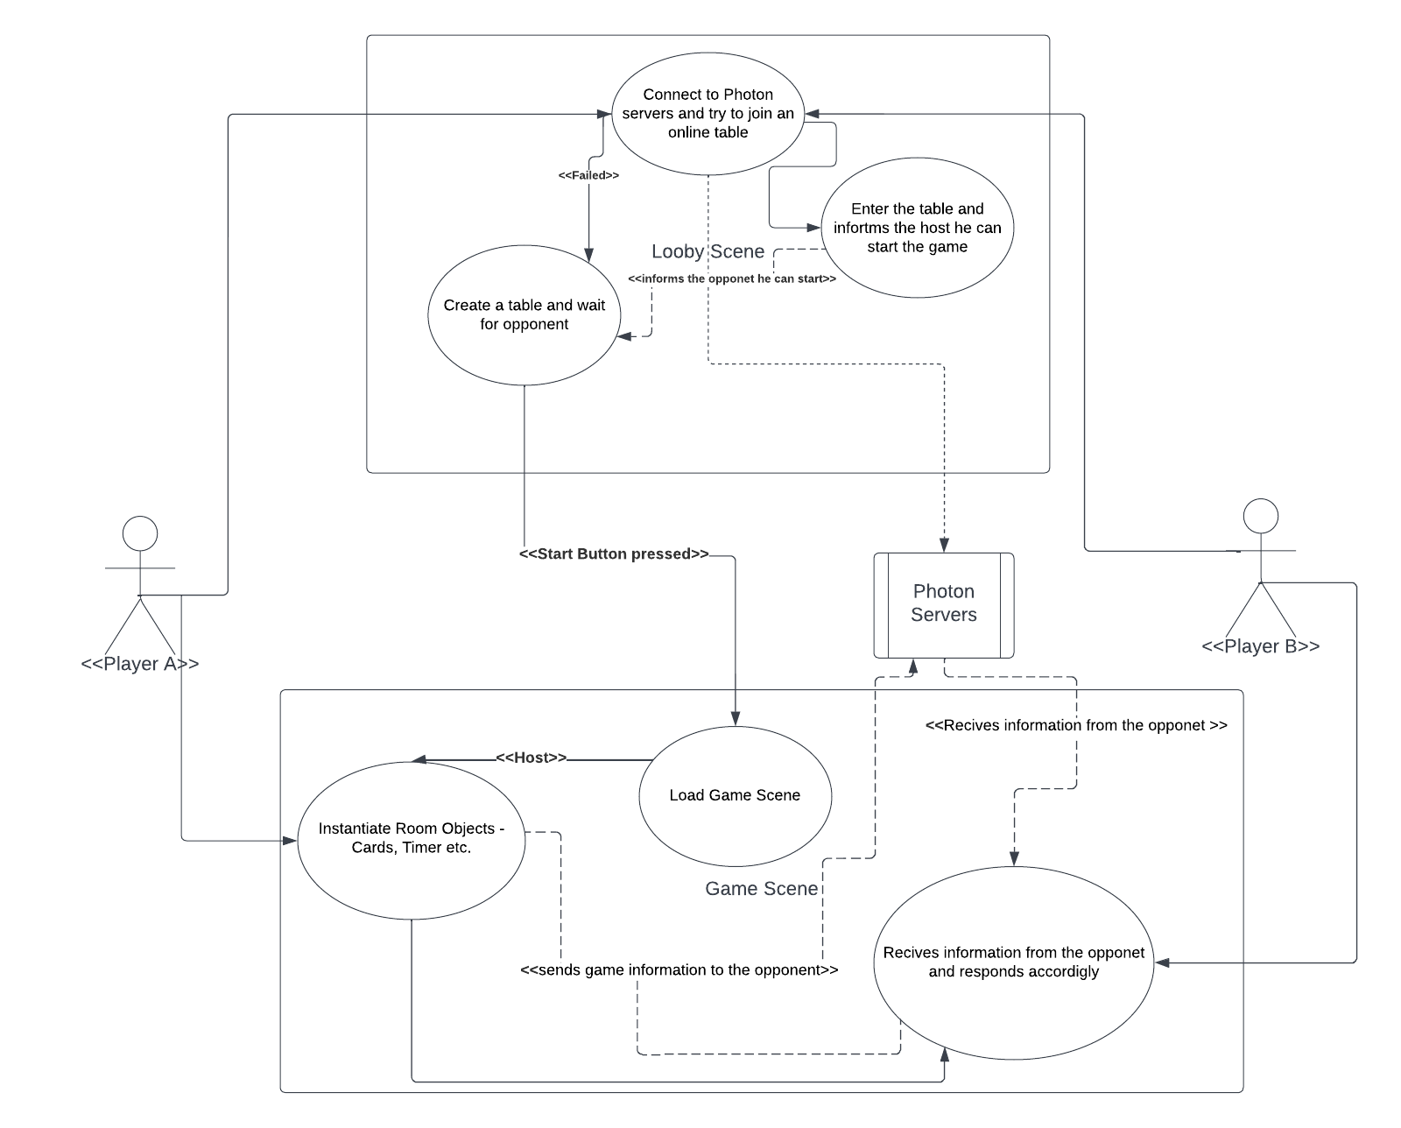

5.2 **UC2:** Betting on Slot Machine Mode

5.2.1 **Brief Description:**

A player enters Slot Machine scene and wish to play his daily bets reward. Every player gets 5 free bets a day without the need to pay gems. If player has already used his 5 bets, he can buy another bet with 1 Gem.

If the user got enough Coins and Gems the system will pick 5 random cards, calculate its rank and reward the player if the rank is greater then zero. Else, the user will get a chance to replace one card with new card from deck by paying half of the original bet price.

5.2.2 **UML Sequence Diagram:** 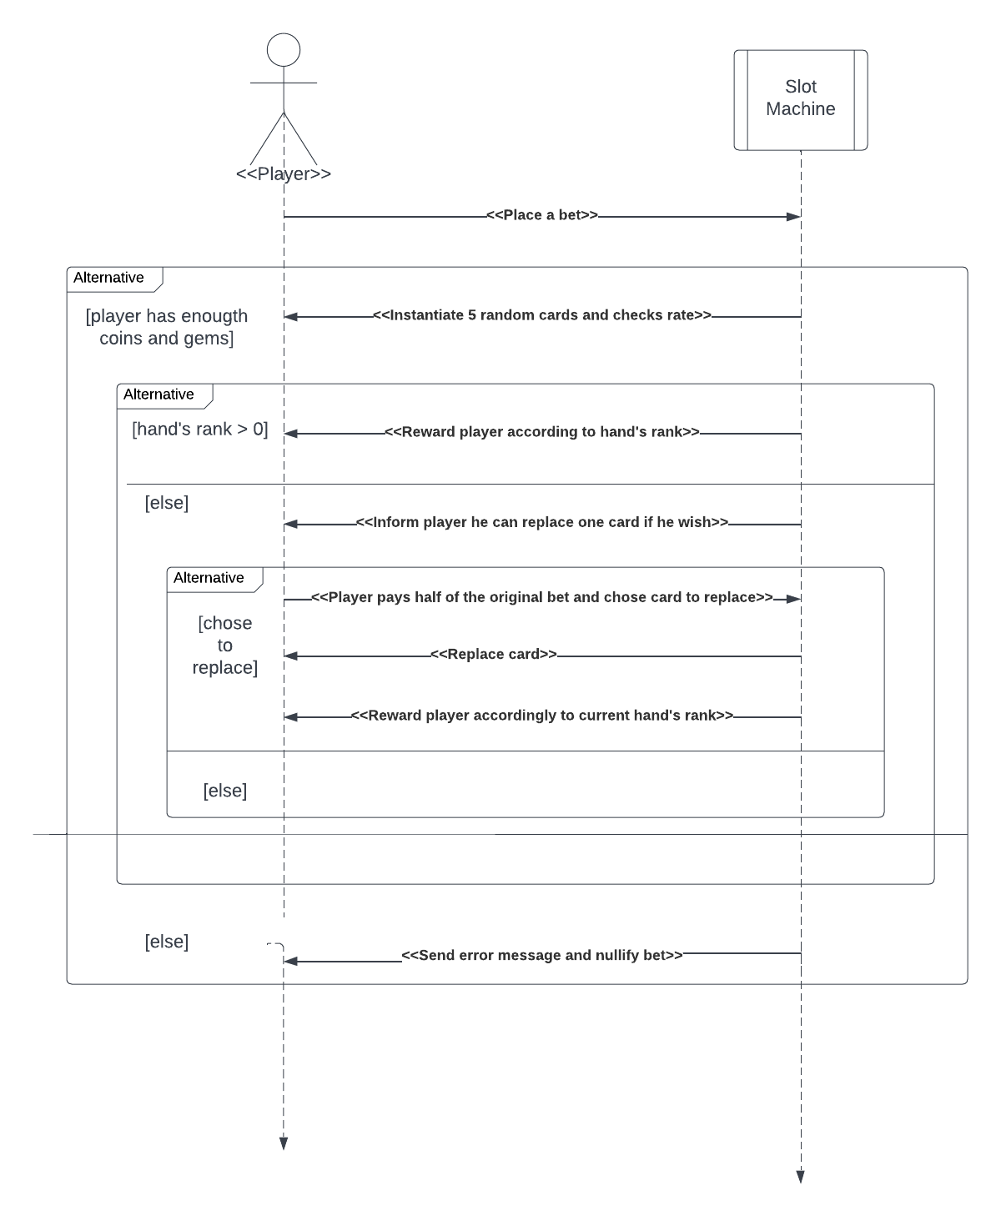

5.2.3 **Use Case Description:**

|  |  |
| --- | --- |
| UC2: Betting on Slot Machine Mode | Use Case |
| G-Req5, G-Req7, N-Req6 | **Related Requirements** |
| Player, Slot Machine System | **Actors** |
| * Encourage players to open the app on a daily basis. * Reward players and help them receive coins. * Another mode to spend time inside the app. | **Goals** |
| * Player got enough free bets/ gems to place a bet. | **Preconditions** |
| The system generated 5 cards, calculate its rate and inform the player whether he won or not. If the player won the system will reward him according to the hand's rate. | **Postconditions** |
| User didn't have enough gems and free bet to play. The bet cancelled. | **Alternative Scenario** |

5.2.4 **Slot Machine Algorithm:**

After picking 5 random cards and calculating hand's rate, the Slot Machine prizing method will reward the player by multiply player's bet by hand's rate value taken from the Rates Vector – vector on floats representing the reward for every possible hand.

In order to guarantee N-Req6 – " In Slot Machine Mode the expected value of daily win rate will be 0.47 while the expected daily revenue will be 1:1", I developed a side-algorithm, running on python that has used a combination between binary searching and statistical hypothesis testing to find proper Rates Vector. The algorithm performed statistical hypothesis tests checking Null hypothesis – "The expected value of win rate is equal to 0.47 and expected value of revenue is 1". The tests were played with different number of subjects every time (N = 1000/5000/15000) with significance level(alpha) equals to 0.05.

5.3 **Uses Stories:**

5.3.1 As a player I want to be able to play Poker Sini games and win coins in Rooms that allow me to bet on different number of coins every time. (G-Req1, G-Req2, G-Req6, N-Req3)

5.3.2 As a player I want to be able to play against an opponent even if we don't share the same mobile operating system. (G-Req1)

5.3.3 As a player I want the system to keep track on my progress in the game and let me know what hands I haven't won yet. (I-Req1, A-Req1, I-Req3)

5.3.4 As a user I want to be able to customize my app and profile. (A-Req2)

5.3.5 As a user I want the app to teach me how to play Poker Sini If I have never played or forgot. (G-Req8)

**6. Scenes and Screenshots:**



6.1 **Lobby Scene:** The main scene of the game. In this scene users will navigate throw all of the game features and scenes, edit game properties, customize user and keep track on achievements. Screenshots show all 4 Lobby scene's skins.



6.2 **Game Scene:** Played in Bot Mode and Tournament Mode offline and with two players in Online Mode. The Scene contains a tutorial for the game and several skins for each Game table.



6.3 **Slot Machine Scene:** Side-Game Scene of the app. In this scene players can open packs they won in playing Poker Sini and be rewarded. This scene can be played in a regular slot machine format when players place a bet and get 5 cards and get better rewards for better hands. This side game is pure game of luck and its goal is to rewards players on a daily basis.



6.4 **Tournament Scene:** Manage all Tournament data – Tour type, game draws, etc.

**7. Prototype development:**

As said previously, this current version of the app was developed as a prototype for my vision to the full Poker Sini App. In order to fulfil its full potential, the app requires resources I as a single developer cannot provide. In this section I'm going to review all segments that are missing in the current version of the app, and explain why it is crucial for the app success.

7.1 **Data security:** As many apps like this game, one of its main profit sources is selling coins, gems and other credits for players to use in the app. Because of that, secure data from been modified is crucial for the app success.

It is also important to mention that storing data in a secure severer will also allow players to keep their account while replacing devices and by that will make it easier to preserve users in the future.

**Current state:** Storing data on a cloud is something I couldn't afford at the moment, so,in this prototype all of player's data and preference is stored locally in the App's Cache. This makes it relatively easy for players to access their data and change it as they wish.

7.2 **Network Servers:** As a game experience growth in his active users, it needs to ensure that user's experience won't decrease. Servers should be able to host several games simultaneously keeping the data on game rooms located in the server.

**Current state:** In current game version, we are using Photon PUN 2 Free server which allowed no more then 100 active users at a time. This makes the server to be unstable and untrusty. In addition, all of the game data is stored on one of the players in order to not over load the servers, which can cause a failure during an online game.

Because of that most of the prototype traffic is focused right now at the Bot Mode, which was build to replace the server.

7.3 **Events and Features:** One of the best ways to keep players re-enter a game and use the app is creating scheduled events and design changing features. One example of event that could work in this type of game is creating weekly hands targets for players to achieve like winning a game only by scoring 5 "Three of a Kind", or winning a game when the 1st hand is equal to the 5th and the 2nd is equal to the 4th. This type of events will not only encourage players to return it can also cause them to lose coins trying to win this prize.

**Current State:** This current prototype is designed to be an app that works without weekly maintenance.

7.3 **Store:** As many apps, a store is a great way to encourage users to spend money and use coins to buy rewards. This App's store will include buying customize card skins like alternate designs or special cards (like Harry Potter's cards or Rick N Morty etc.).

**Current State:** In order to focus on improving the gaming skill of the game and keeping the app size as small as possible, at the moment I decided not to include a Store inside the game, but I do think it is crucial in the final version of the App.